Practical No:1
Study of Networking Devices
IP Address
Q1:- Identify the network address & subnet mask for the IP address 192.168.1.0
→ Given IP Address is 192.168.1.0
∴ The subnet mask is 255.255.255.0 (as it belongs to Class C)
In binary form:
11111111.11111111.11111111.00000000
Q2: Create 4 subnets
→ To create 4 subnets we need to borrow 2 bits from the host part
∴ 2² = 4
So, the new subnet mask is 255.255.255.192
Binary form:
11111111.11111111.11111111.11000000
:26 bits for the network part, 6 bits for the host part
:Total number of subnets = 4
(Combining 2 or more subnets will give us the supernet.)
Total no of usable IP addresses in each subnet is 64 − 2 because 1 address is for network and 1 for broadcast so subtracting them.
62 IP addresses are usable.
CIDR format (Classless Inter-Domain Representation)
new subnet mask: 255.255.255.192/26
The 1st subnet is 192.168.1.0/26
The 2nd subnet is 192.168.1.64/26
subnet 1 = 192.168.1.0 → network address
usable host address: 192.168.1.62/26
broadcast address: 192.168.1.63/26
subnet 2 = 192.168.1.64
1st host address: 192.168.1.65
last host address: 192.168.1.126/26
broadcast address: 192.168.1.127
subnet 3 = 192.168.1.128
last address is 192.168.1.190
1st address is 192.168.1.129
subnet 4 = 192.168.1.192
last host address: 192.168.1.254
broadcast address: 192.168.1.255
Q.3 A network address 192.168.1.0/24
Create 3 subnet with subnet 1 consisting of 50, subnet 2 with 20 IP and subnet 3 with 10.
(Since the no of host bit is determine on IP address. IP address formula to calculate no of bits required to satisfy each subnet IP address is 2^n >= no of IP address required + 2
where n is the no of host bits and +2 represent n/ b)
Subnet 1 of 50 IP address
2^6 = 64 with 62 usable IP address
we need 6 host bits
Subnet mask is 255.255.255.192 (/26)
2^5 = 32 → 30 usable
Subnet mask is 255.255.255.224 (/27)
2^4 = 16
Subnet mask 255.255.255.240 (/28)
Subnet 1:
Subnet mask: 255.255.255.192 (/26)
Network address: 192.168.1.0/26
1st host address: 192.168.1.1/26
Last host address: 192.168.1.62/26
Usable IP address: 62
Broadcast: 192.168.1.63/26

Practical No:2
Demonstrate Static Routing
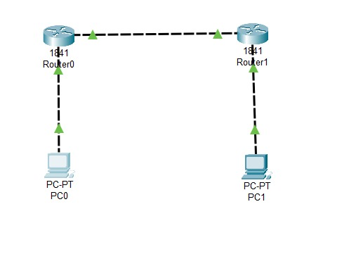
Router 0
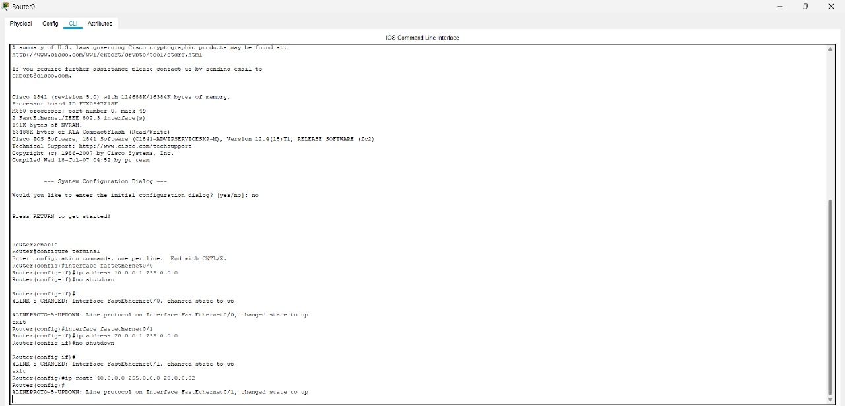
Router 1
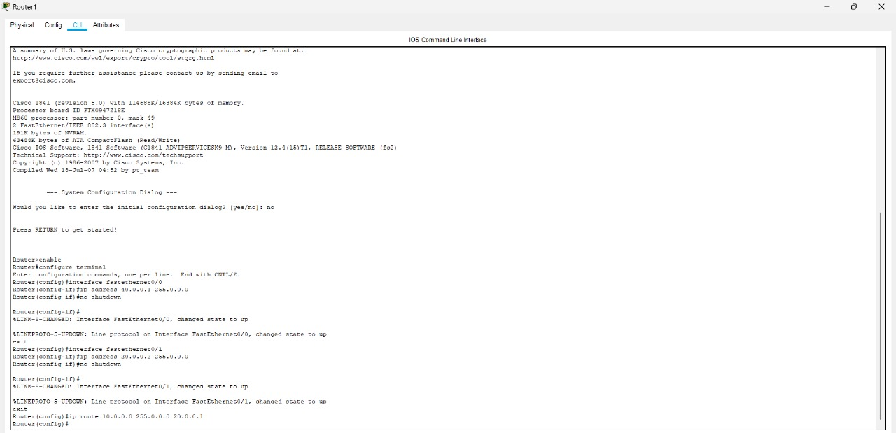
PC 0
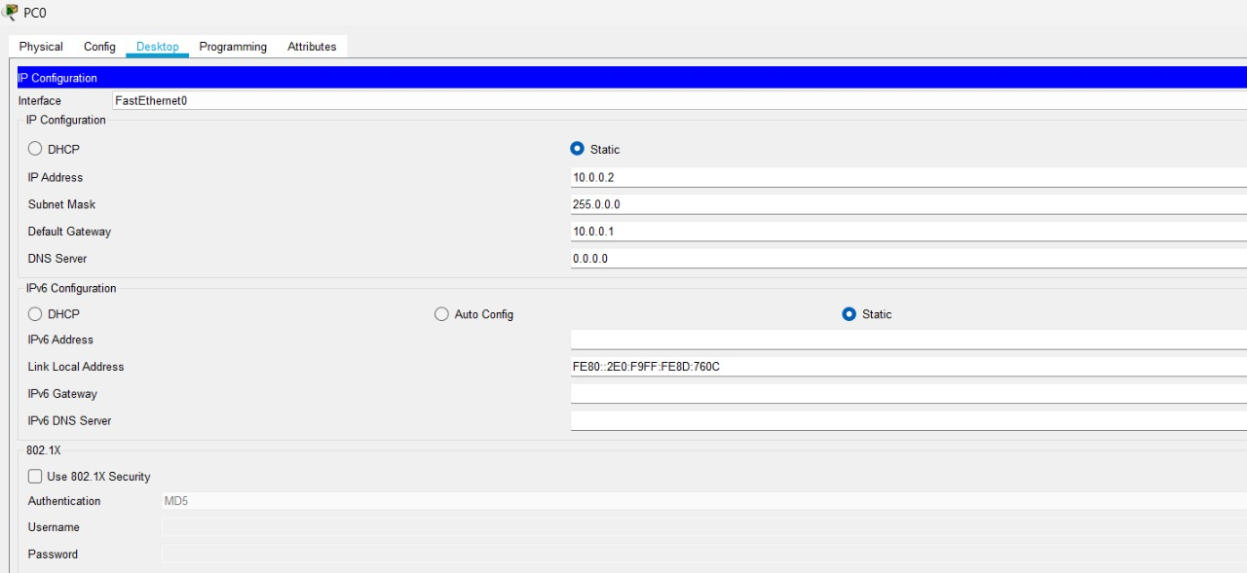
PC 1
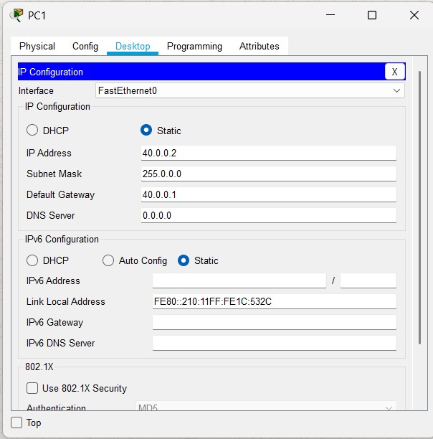
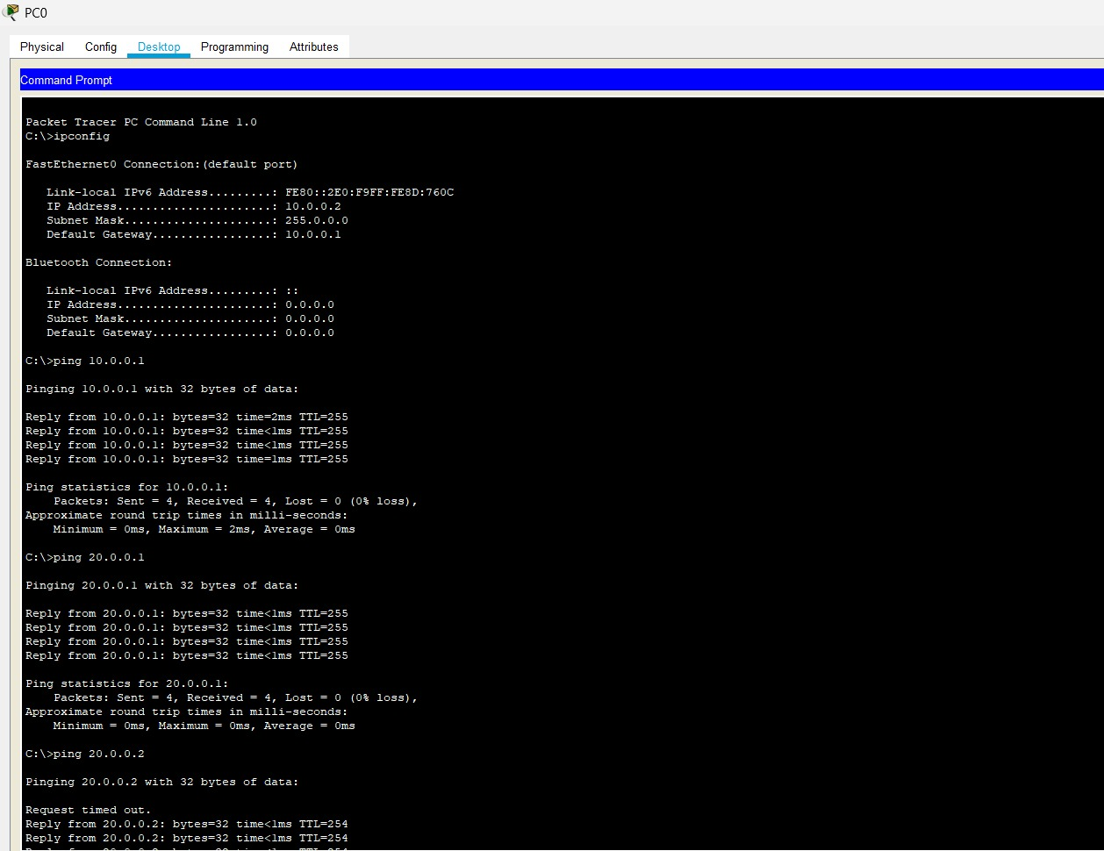
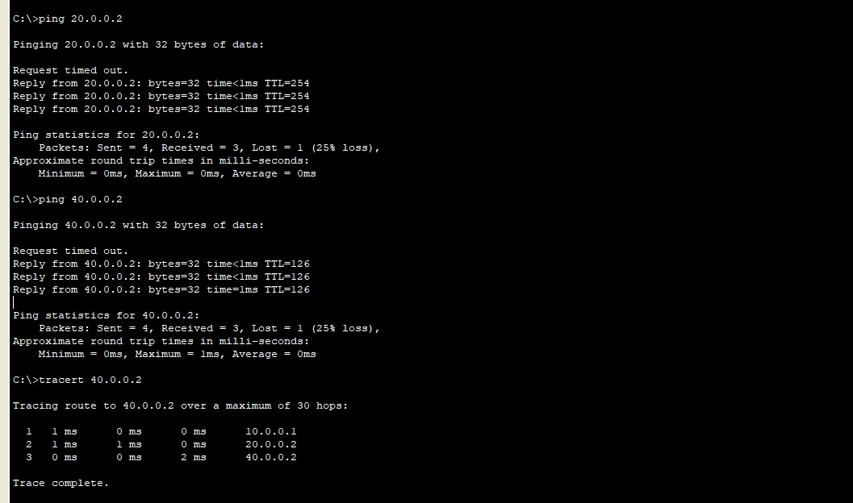
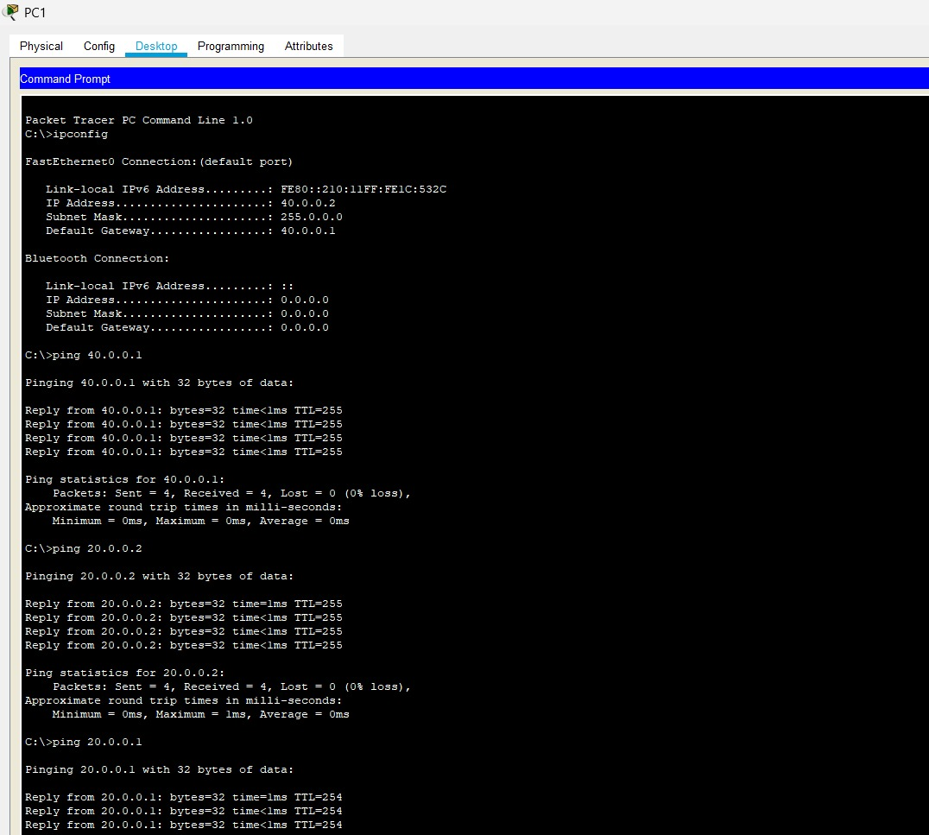
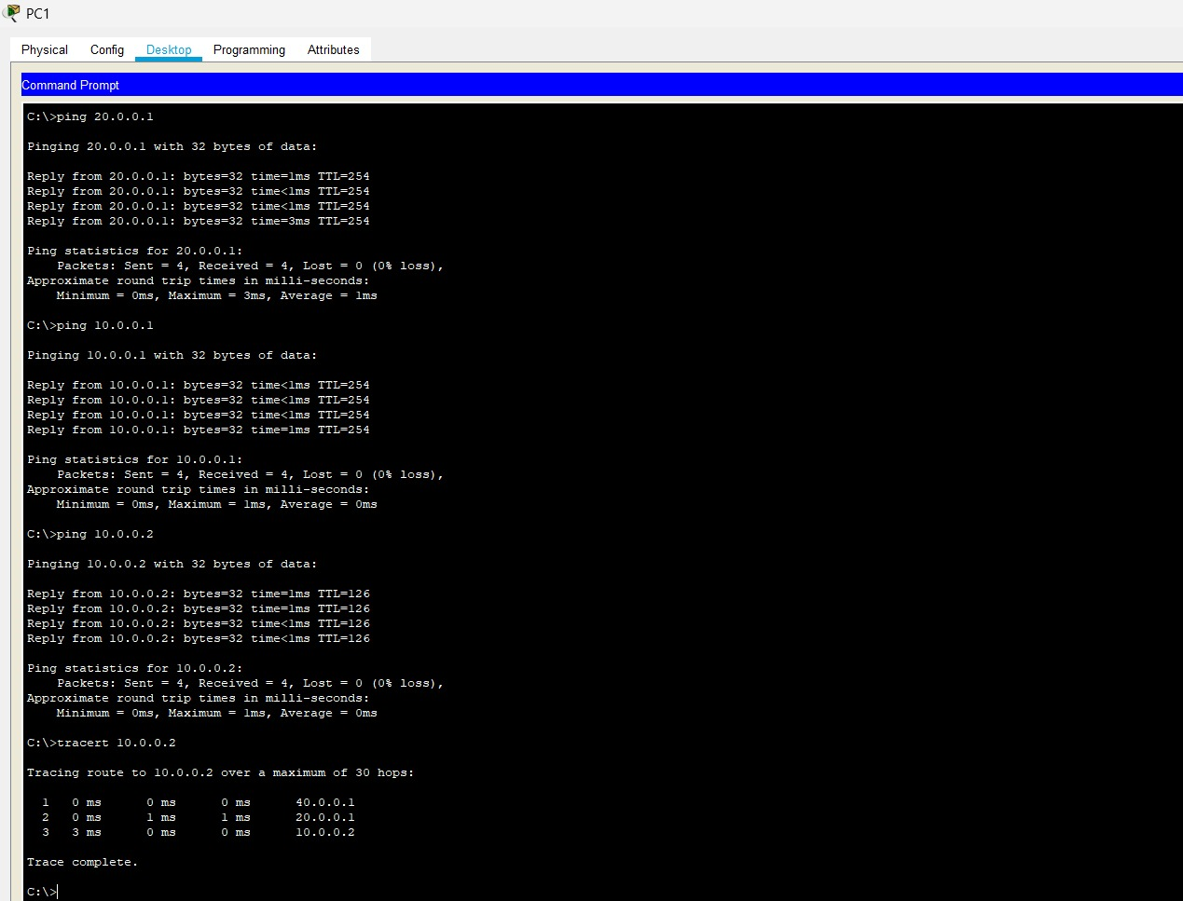

Demonstrate Routing Ospf in Packet tracer
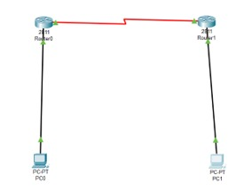
Router 0
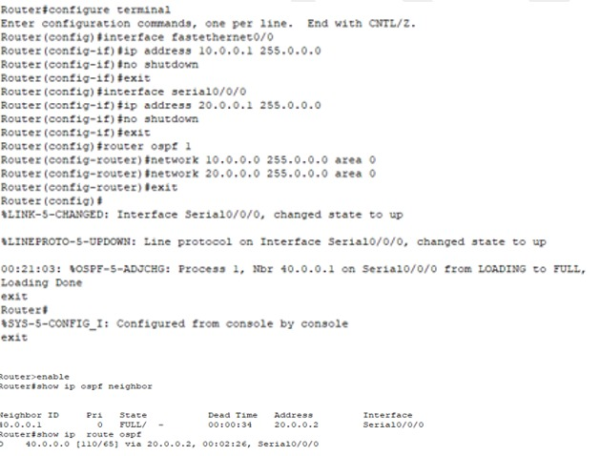

Router 1
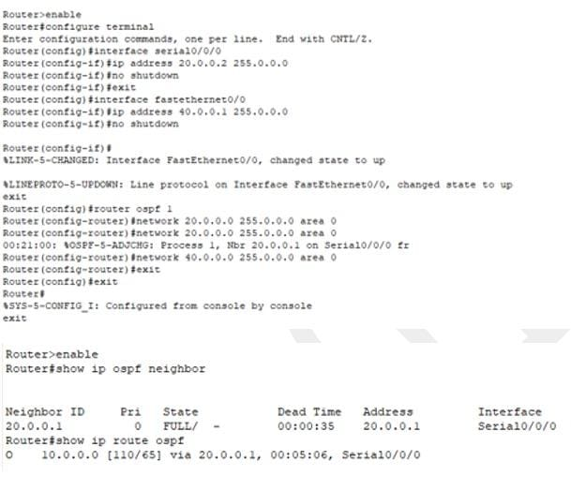

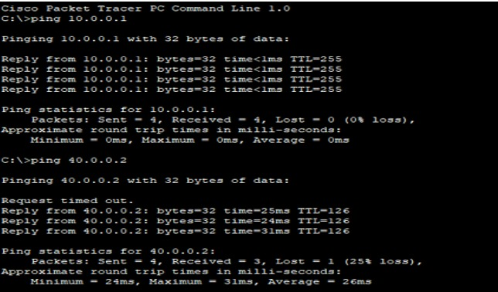

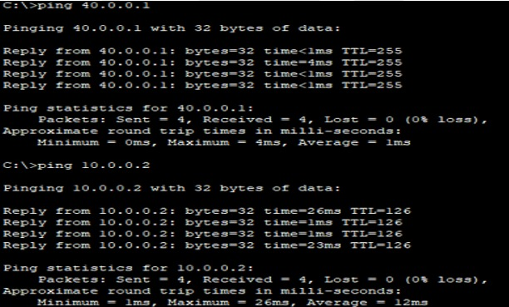

Demonstrate Routing RIP in Packet tracer
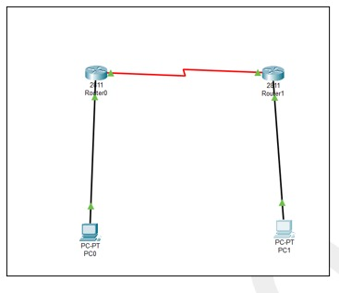
Router 0
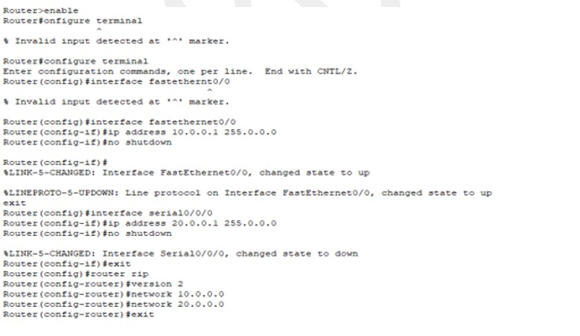
Router 1
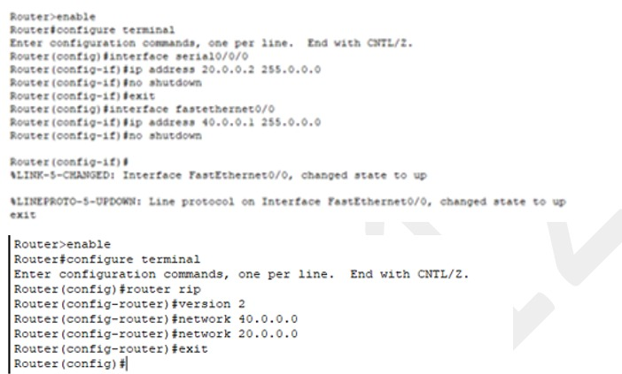
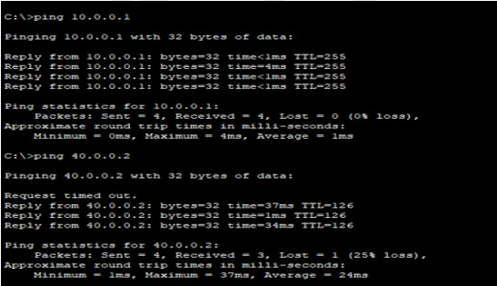
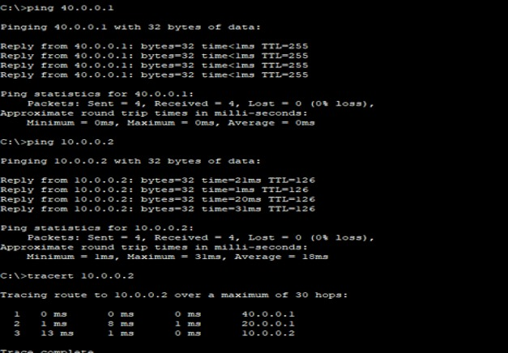

PRACTICAL NO:3
Demonstrate Dhcp
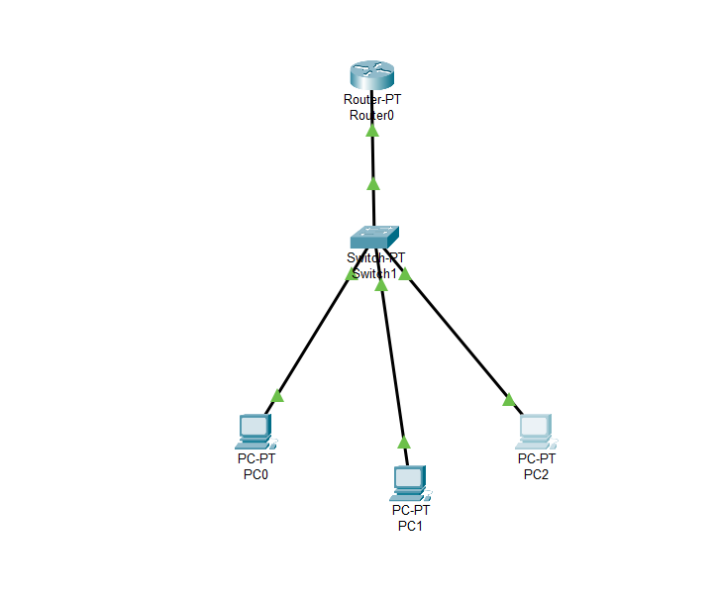

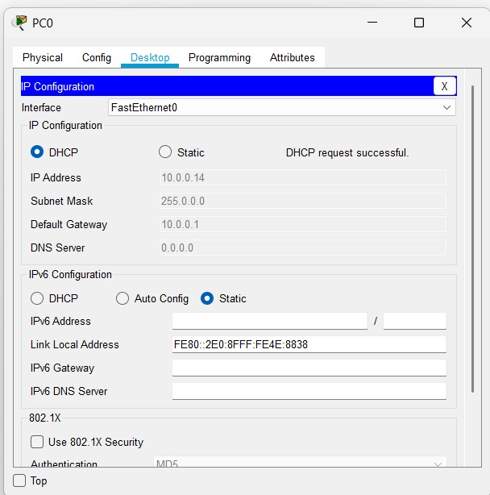
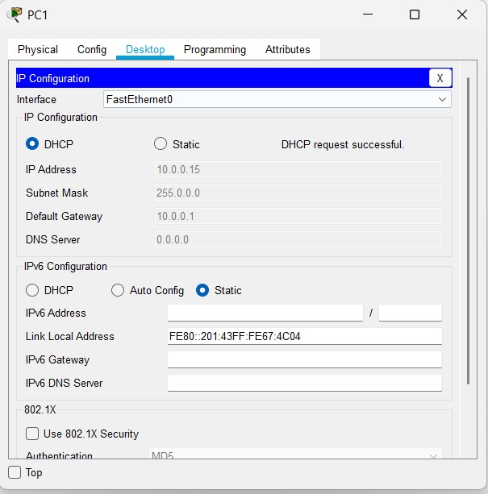

Demonstrate Dns
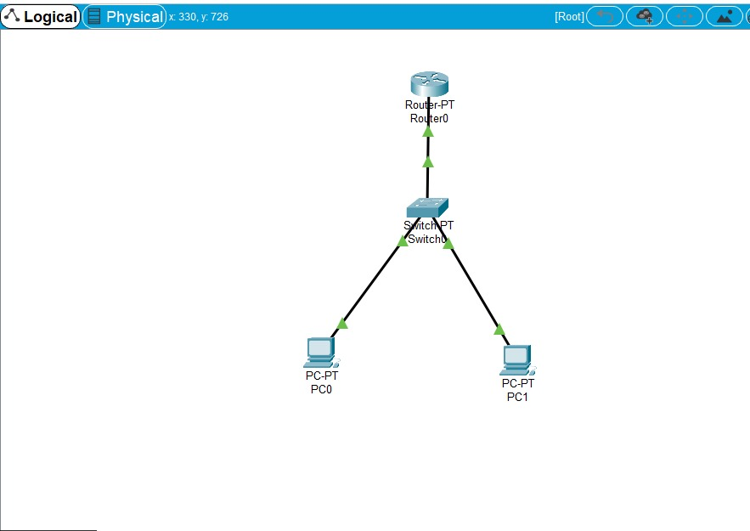
Router 0
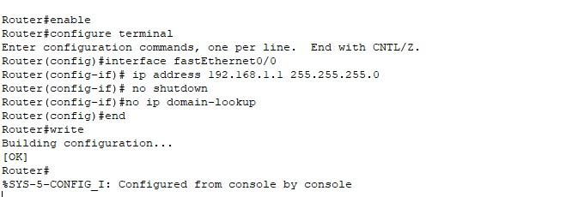
PC 0
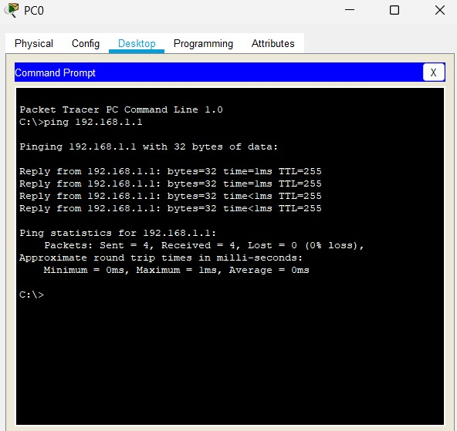
PC 1
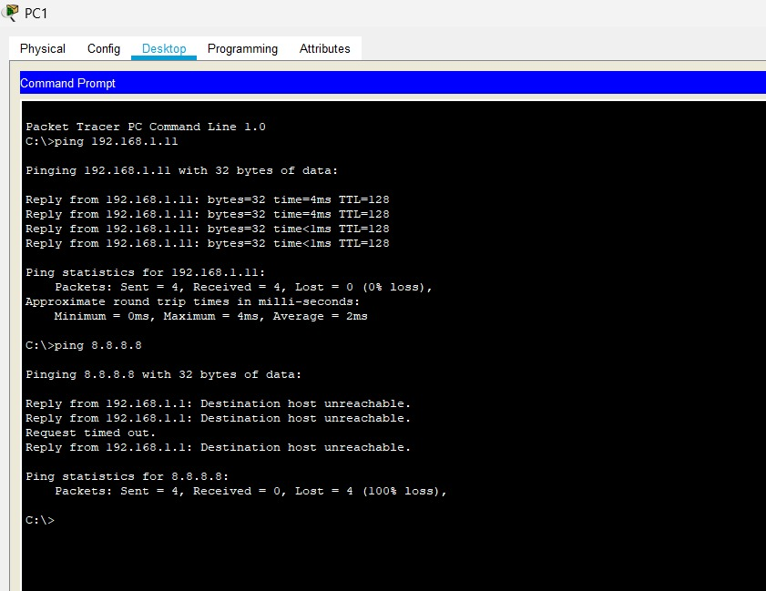

Demonstrate FTP

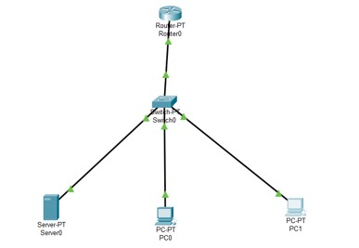
Router 0
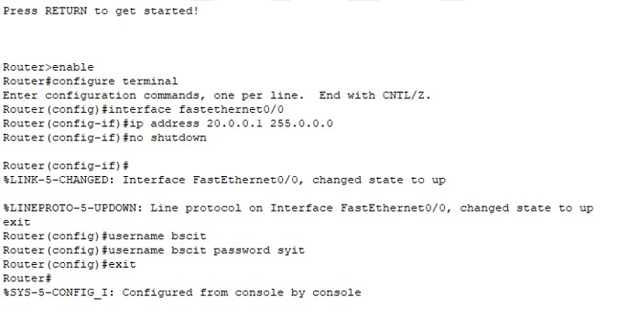
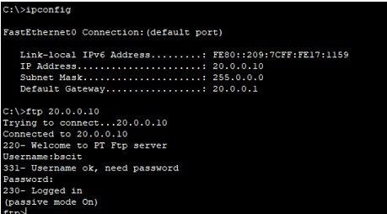
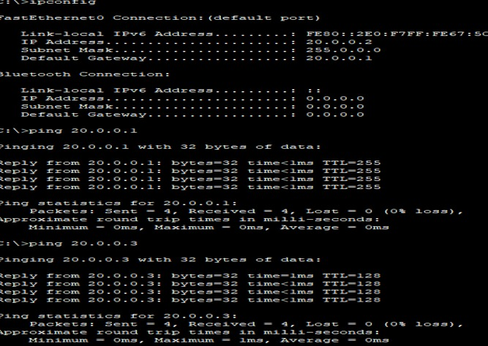
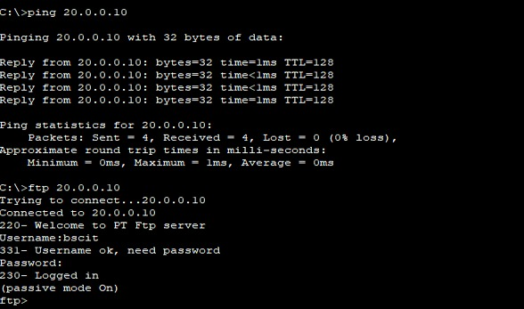

Practical NO:4
Study of Cyptographhy-Substitution Techniques
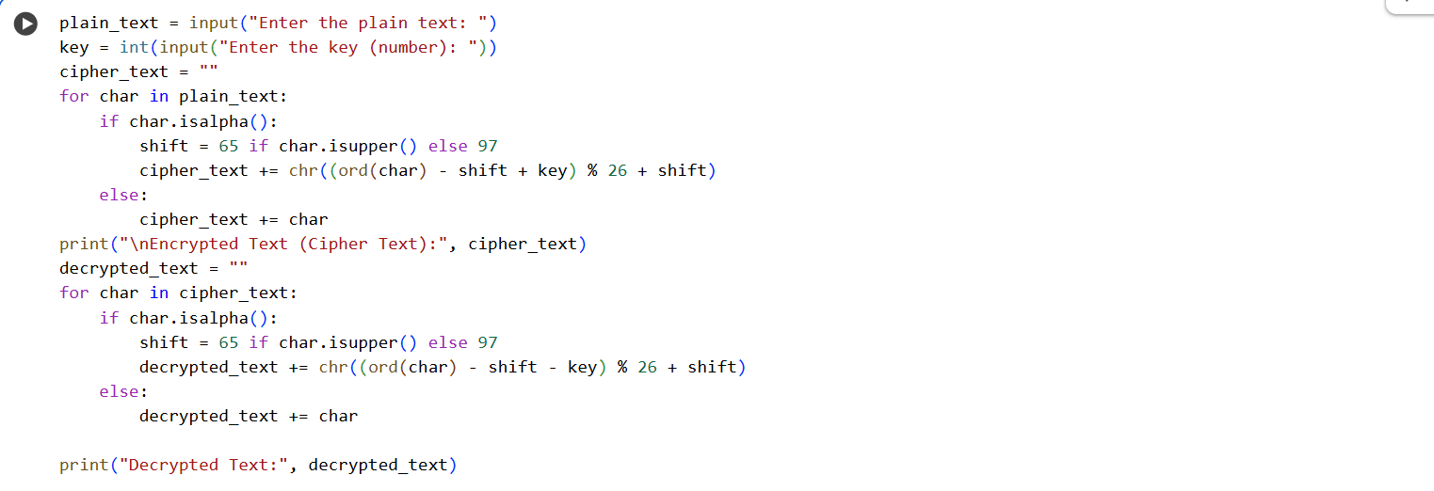

Output:
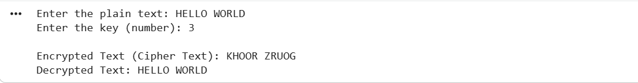

PRACTICAL NO:5
Study of Symmetric Key
Demonstrate AES
Program:
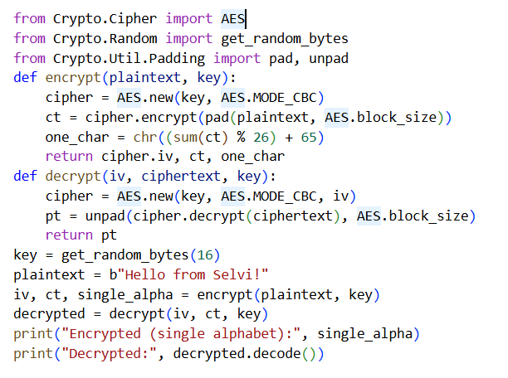
Output:

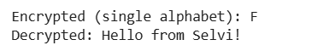

Demonstrate DES
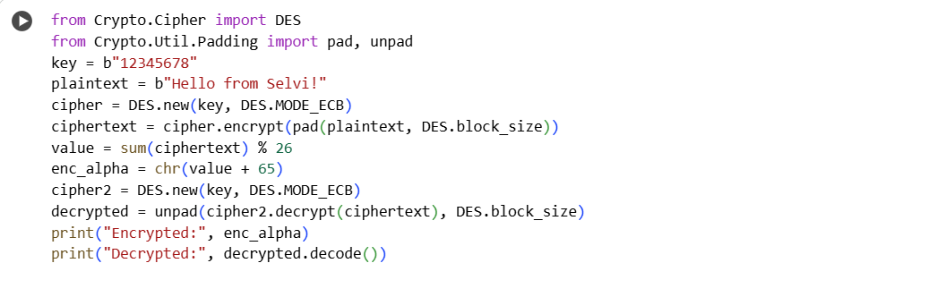
Output:

PRACTICAL NO:6
Study of Assymetric Key
Demonstrate RSA
Program:
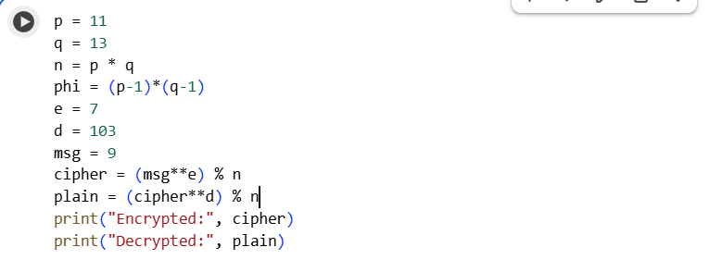
Output:

PRACTICAL NO:7
Demonstrate MD5
Program:
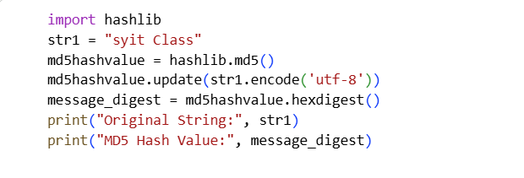
Output:
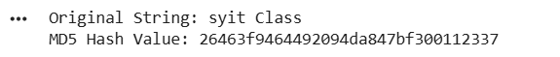

PRACTICAL NO:8
Demonstrate Hash Function
Program:
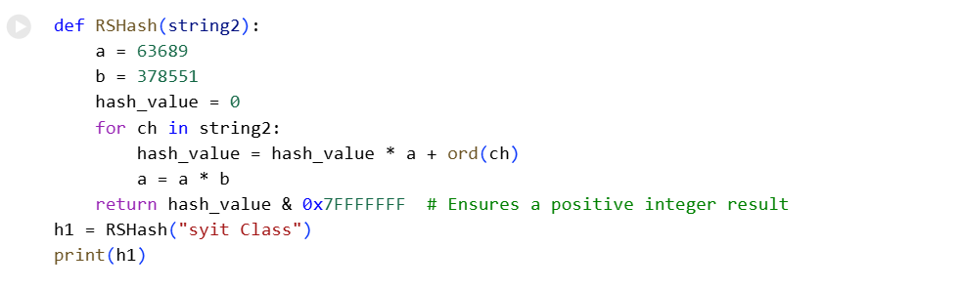
Output:
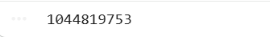

PRACTICAL NO:9
To Create ,Export and validate a digital certificate
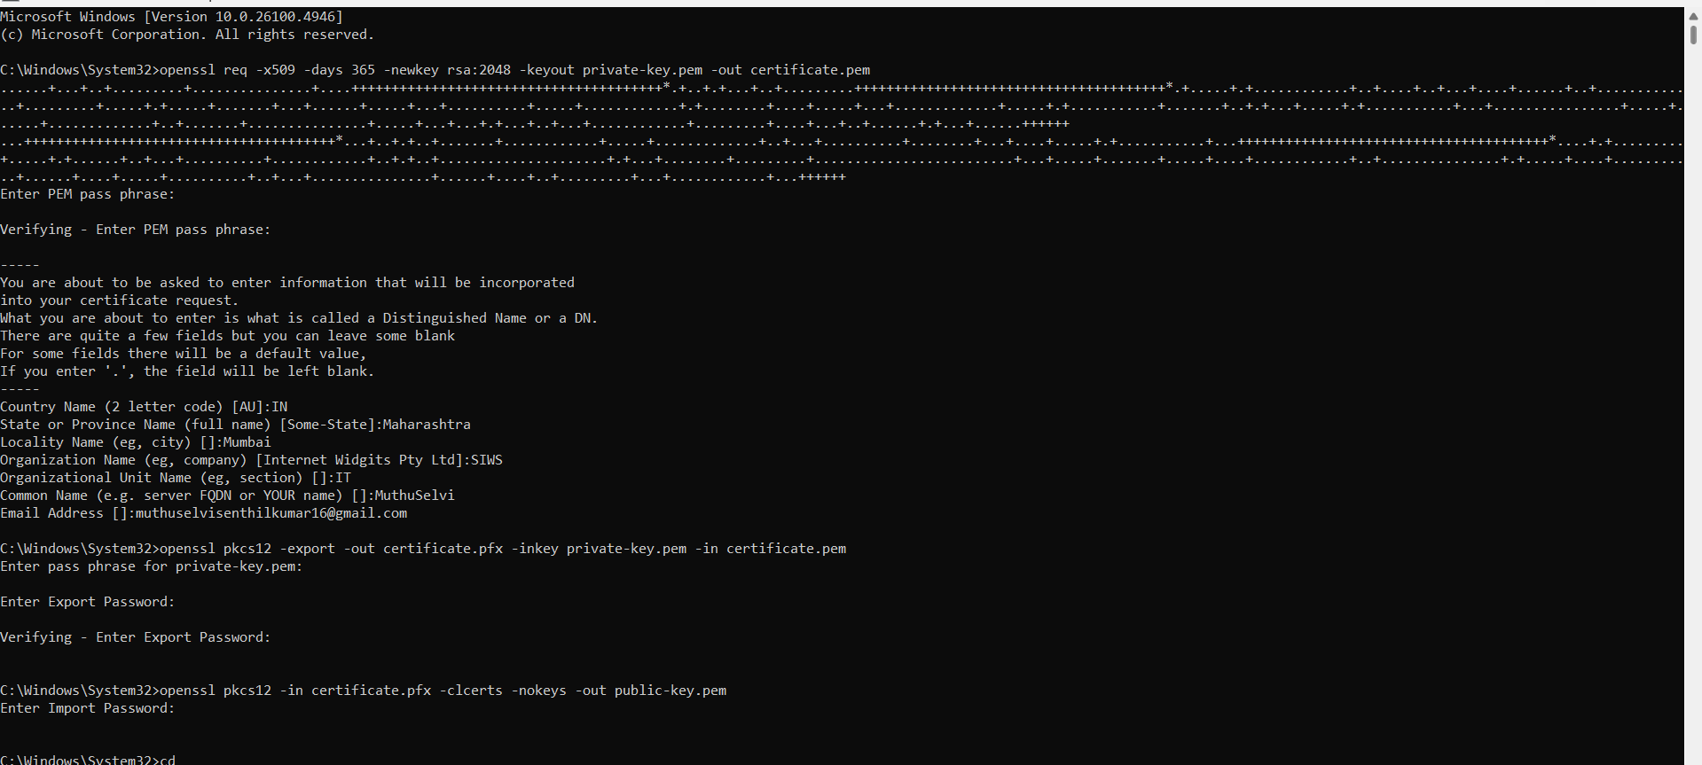
Output:
